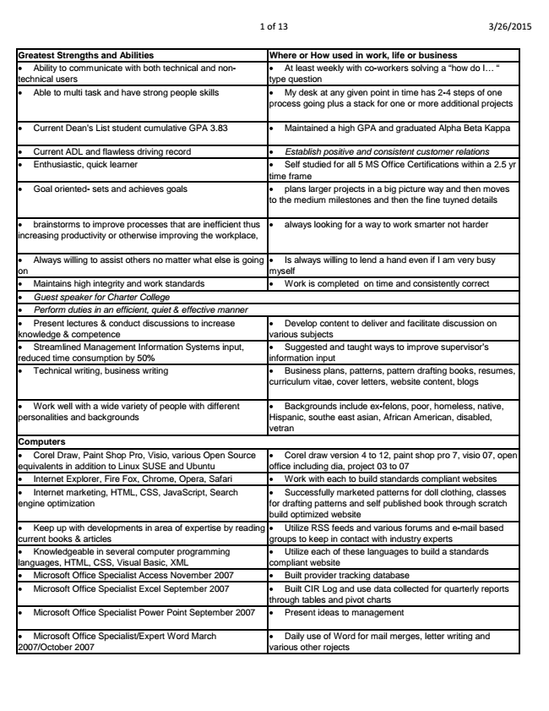

1 of 13 3/26/2015

**Greatest Strengths and Abilities Where or How used in work, life or business**

• Ability to communicate with both technical and non- technical users

• At least weekly with co-workers solving a “how do I... “ type question

• Able to multi task and have strong people skills • My desk at any given point in time has 2-4 steps of one

process going plus a stack for one or more additional projects

• Current Dean's List student cumulative GPA 3.83 • Maintained a high GPA and graduated Alpha Beta Kappa

*• Current ADL and flawless driving record • Establish positive and consistent customer relations*

• Enthusiastic, quick learner • Self studied for all 5 MS Office Certifications within a 2.5 yr

time frame

• Goal oriented- sets and achieves goals • plans larger projects in a big picture way and then moves

to the medium milestones and then the fine tuyned details

• brainstorms to improve processes that are inefficient thus increasing productivity or otherwise improving the workplace,

• always looking for a way to work smarter not harder

• Always willing to assist others no matter what else is going on

• Is always willing to lend a hand even if I am very busy myself

• Maintains high integrity and work standards • Work is completed on time and consistently correct

*• Guest speaker for Charter College*

*• Perform duties in an efficient, quiet & effective manner*

• Present lectures & conduct discussions to increase knowledge & competence

**Computers**

• Develop content to deliver and facilitate discussion on various subjects

• Streamlined Management Information Systems input, reduced time consumption by 50%

• Suggested and taught ways to improve supervisor’s information input

• Technical writing, business writing • Business plans, patterns, pattern drafting books, resumes,

curriculum vitae, cover letters, website content, blogs

• Work well with a wide variety of people with different personalities and backgrounds

• Backgrounds include ex-felons, poor, homeless, native, Hispanic, southe east asian, African American, disabled, vetran

• Corel Draw, Paint Shop Pro, Visio, various Open Source equivalents in addition to Linux SUSE and Ubuntu

• Corel draw version 4 to 12, paint shop pro 7, visio 07, open office including dia, project 03 to 07

• Internet Explorer, Fire Fox, Chrome, Opera, Safari • Work with each to build standards compliant websites

• Internet marketing, HTML, CSS, JavaScript, Search engine optimization

• Successfully marketed patterns for doll clothing, classes for drafting patterns and self published book through scratch build optimized website

• Keep up with developments in area of expertise by reading current books & articles

• Utilize RSS feeds and various forums and e-mail based groups to keep in contact with industry experts

• Knowledgeable in several computer programming languages, HTML, CSS, Visual Basic, XML

• Utilize each of these languages to build a standards compliant website

• Microsoft Office Specialist Access November 2007 • Built provider tracking database

• Microsoft Office Specialist Excel September 2007 • Built CIR Log and use data collected for quarterly reports

through tables and pivot charts

• Microsoft Office Specialist Power Point September 2007 • Present ideas to management

• Microsoft Office Specialist/Expert Word March 2007/October 2007

• Daily use of Word for mail merges, letter writing and various other rojects

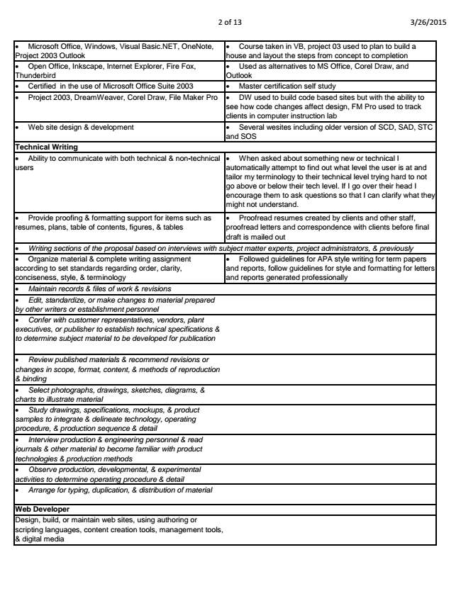

2 of 13 3/26/2015

• Microsoft Office, Windows, Visual Basic.NET, OneNote, Project 2003 Outlook

• Course taken in VB, project 03 used to plan to build a house and layout the steps from concept to completion

• Open Office, Inkscape, Internet Explorer, Fire Fox, Thunderbird

• Used as alternatives to MS Office, Corel Draw, and Outlook

• Certified in the use of Microsoft Office Suite 2003 • Master certification self study

• Project 2003, DreamWeaver, Corel Draw, File Maker Pro • DW used to build code based sites but with the ability to

see how code changes affect design, FM Pro used to track clients in computer instruction lab

• Web site design & development • Several wesites including older version of SCD, SAD, STC

**and SOS Technical Writing**

• Ability to communicate with both technical & non-technical users

*• Writing sections of the proposal based on interviews with subject matter experts, project administrators, & previously*

**Web Developer**

• When asked about something new or technical I automatically attempt to find out what level the user is at and tailor my terminology to their technical level trying hard to not go above or below their tech level. If I go over their head I encourage them to ask questions so that I can clarify what they might not understand.

• Provide proofing & formatting support for items such as resumes, plans, table of contents, figures, & tables

• Proofread resumes created by clients and other staff, proofread letters and correspondence with clients before final draft is mailed out

• Organize material & complete writing assignment according to set standards regarding order, clarity, conciseness, style, & terminology

• Followed guidelines for APA style writing for term papers and reports, follow guidelines for style and formatting for letters and reports generated professionally

*• Maintain records & files of work & revisions*

*• Edit, standardize, or make changes to material prepared by other writers or establishment personnel*

*• Confer with customer representatives, vendors, plant executives, or publisher to establish technical specifications & to determine subject material to be developed for publication*

*• Review published materials & recommend revisions or changes in scope, format, content, & methods of reproduction & binding*

*• Select photographs, drawings, sketches, diagrams, & charts to illustrate material*

*• Study drawings, specifications, mockups, & product samples to integrate & delineate technology, operating procedure, & production sequence & detail*

*• Interview production & engineering personnel & read journals & other material to become familiar with product technologies & production methods*

*• Observe production, developmental, & experimental activities to determine operating procedure & detail*

*• Arrange for typing, duplication, & distribution of material*

Design, build, or maintain web sites, using authoring or scripting languages, content creation tools, management tools, & digital media

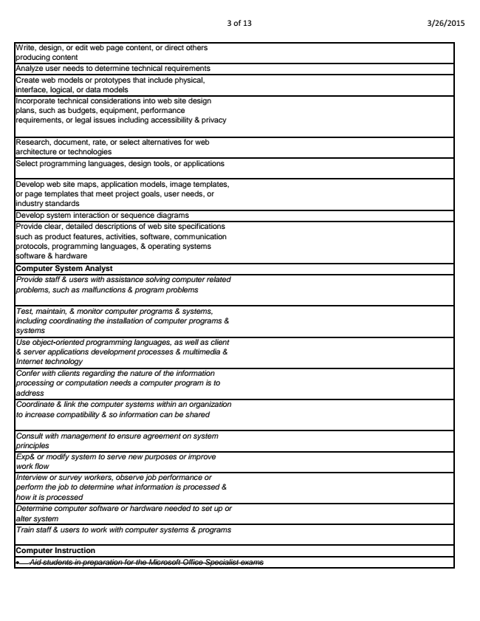

3 of 13 3/26/2015

Write, design, or edit web page content, or direct others producing content Analyze user needs to determine technical requirements Create web models or prototypes that include physical, interface, logical, or data models Incorporate technical considerations into web site design plans, such as budgets, equipment, performance requirements, or legal issues including accessibility & privacy

Research, document, rate, or select alternatives for web architecture or technologies Select programming languages, design tools, or applications

Develop web site maps, application models, image templates, or page templates that meet project goals, user needs, or industry standards Develop system interaction or sequence diagrams Provide clear, detailed descriptions of web site specifications such as product features, activities, software, communication protocols, programming languages, & operating systems software & hardware Computer System Analyst Provide staff & users with assistance solving computer related problems, such as malfunctions & program problems

*Test, maintain, & monitor computer programs & systems, including coordinating the installation of computer programs & systems Use object-oriented programming languages, as well as client & server applications development processes & multimedia & Internet technology Confer with clients regarding the nature of the information processing or computation needs a computer program is to address Coordinate & link the computer systems within an organization to increase compatibility & so information can be shared*

*Consult with management to ensure agreement on system principles Exp& or modify system to serve new purposes or improve work flow Interview or survey workers, observe job performance or perform the job to determine what information is processed & how it is processed Determine computer software or hardware needed to set up or alter system Train staff & users to work with computer systems & programs*

**Computer Instruction**

*• Aid students in preparation for the Microsoft Office Specialist exams*

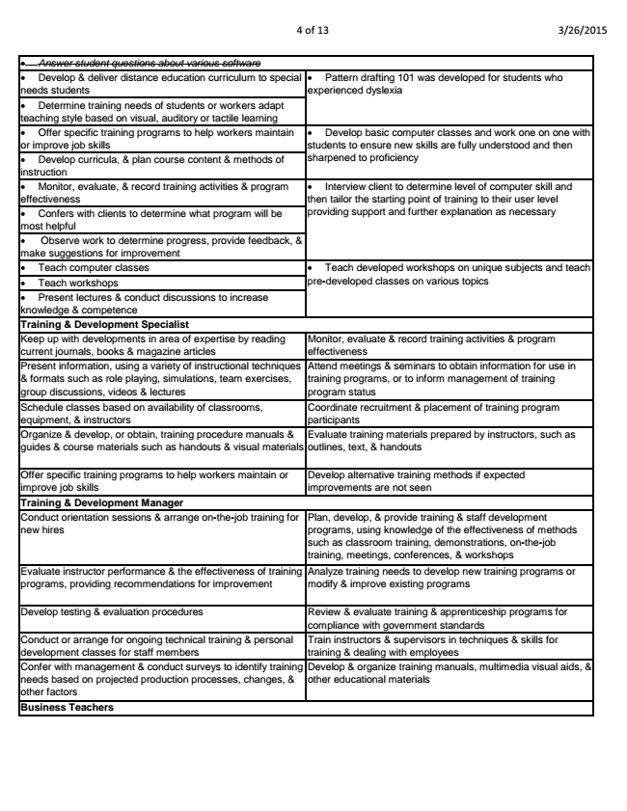

4 of 13 3/26/2015

*• Answer student questions about various software*

• Develop & deliver distance education curriculum to special

• Pattern drafting 101 was developed for students who needs students

experienced dyslexia

• Determine training needs of students or workers adapt teaching style based on visual, auditory or tactile learning

• Offer specific training programs to help workers maintain

• Develop basic computer classes and work one on one with or improve job skills

students to ensure new skills are fully understood and then

• Develop curricula, & plan course content & methods of

sharpened to proficiency instruction

• Monitor, evaluate, & record training activities & program

• Interview client to determine level of computer skill and effectiveness

then tailor the starting point of training to their user level

• Confers with clients to determine what program will be

providing support and further explanation as necessary most helpful

• Observe work to determine progress, provide feedback, & make suggestions for improvement

• Teach computer classes

• Teach workshops

• Present lectures & conduct discussions to increase knowledge & competence

Keep up with developments in area of expertise by reading current journals, books & magazine articles

• Teach developed workshops on unique subjects and teach pre-developed classes on various topics

**Training & Development Specialist**

**Training & Development Manager**

**Business Teachers**

Monitor, evaluate & record training activities & program effectiveness Present information, using a variety of instructional techniques & formats such as role playing, simulations, team exercises, group discussions, videos & lectures

Attend meetings & seminars to obtain information for use in training programs, or to inform management of training program status Schedule classes based on availability of classrooms, equipment, & instructors

Coordinate recruitment & placement of training program participants Organize & develop, or obtain, training procedure manuals & guides & course materials such as handouts & visual materials

Evaluate training materials prepared by instructors, such as outlines, text, & handouts

Offer specific training programs to help workers maintain or improve job skills

Develop alternative training methods if expected improvements are not seen

Conduct orientation sessions & arrange on-the-job training for new hires

Plan, develop, & provide training & staff development programs, using knowledge of the effectiveness of methods such as classroom training, demonstrations, on-the-job training, meetings, conferences, & workshops Evaluate instructor performance & the effectiveness of training programs, providing recommendations for improvement

Analyze training needs to develop new training programs or modify & improve existing programs

Develop testing & evaluation procedures Review & evaluate training & apprenticeship programs for

compliance with government standards Conduct or arrange for ongoing technical training & personal development classes for staff members

Train instructors & supervisors in techniques & skills for training & dealing with employees Confer with management & conduct surveys to identify training needs based on projected production processes, changes, & other factors

Develop & organize training manuals, multimedia visual aids, & other educational materials

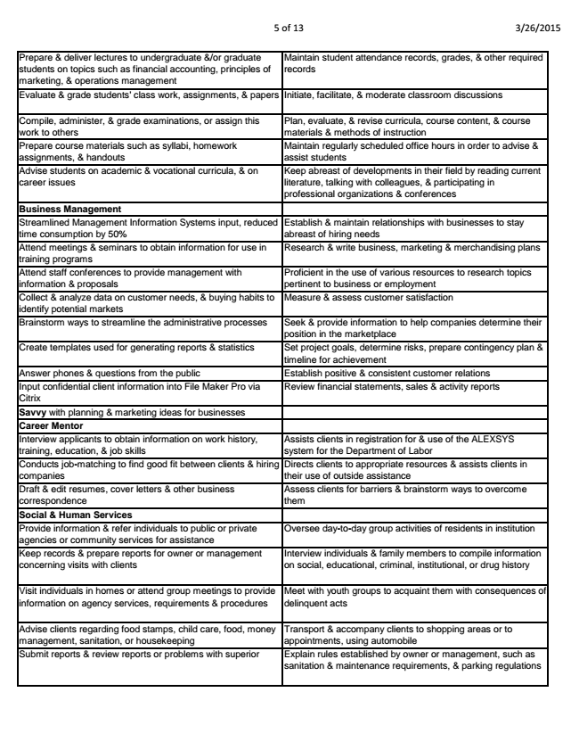

5 of 13 3/26/2015

Prepare & deliver lectures to undergraduate &/or graduate students on topics such as financial accounting, principles of marketing, & operations management

Maintain student attendance records, grades, & other required records

Evaluate & grade students' class work, assignments, & papers Initiate, facilitate, & moderate classroom discussions

Compile, administer, & grade examinations, or assign this work to others

Plan, evaluate, & revise curricula, course content, & course materials & methods of instruction Prepare course materials such as syllabi, homework assignments, & handouts

Maintain regularly scheduled office hours in order to advise & assist students Advise students on academic & vocational curricula, & on career issues

Keep abreast of developments in their field by reading current literature, talking with colleagues, & participating in professional organizations & conferences Business Management Streamlined Management Information Systems input, reduced time consumption by 50%

Establish & maintain relationships with businesses to stay abreast of hiring needs Attend meetings & seminars to obtain information for use in training programs

Research & write business, marketing & merchandising plans

Attend staff conferences to provide management with information & proposals

Proficient in the use of various resources to research topics pertinent to business or employment Collect & analyze data on customer needs, & buying habits to identify potential markets

Measure & assess customer satisfaction

Brainstorm ways to streamline the administrative processes Seek & provide information to help companies determine their

position in the marketplace Create templates used for generating reports & statistics Set project goals, determine risks, prepare contingency plan &

timeline for achievement Answer phones & questions from the public Establish positive & consistent customer relations Input confidential client information into File Maker Pro via Citrix

Review financial statements, sales & activity reports

Savvy with planning & marketing ideas for businesses Career Mentor Interview applicants to obtain information on work history, training, education, & job skills

Assists clients in registration for & use of the ALEXSYS system for the Department of Labor Conducts job-matching to find good fit between clients & hiring companies

Directs clients to appropriate resources & assists clients in their use of outside assistance Draft & edit resumes, cover letters & other business correspondence

Assess clients for barriers & brainstorm ways to overcome them Social & Human Services Provide information & refer individuals to public or private agencies or community services for assistance

Oversee day-to-day group activities of residents in institution

Keep records & prepare reports for owner or management concerning visits with clients

Interview individuals & family members to compile information on social, educational, criminal, institutional, or drug history

Visit individuals in homes or attend group meetings to provide information on agency services, requirements & procedures

Meet with youth groups to acquaint them with consequences of delinquent acts

Advise clients regarding food stamps, child care, food, money management, sanitation, or housekeeping

Transport & accompany clients to shopping areas or to appointments, using automobile Submit reports & review reports or problems with superior Explain rules established by owner or management, such as

sanitation & maintenance requirements, & parking regulations

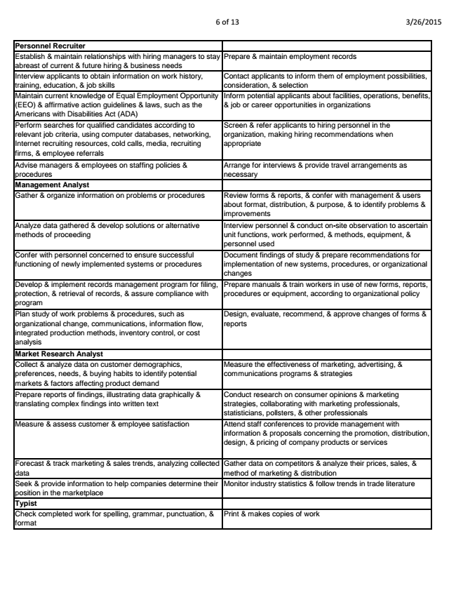

6 of 13 3/26/2015

Personnel Recruiter Establish & maintain relationships with hiring managers to stay abreast of current & future hiring & business needs

Prepare & maintain employment records

Interview applicants to obtain information on work history, training, education, & job skills

Contact applicants to inform them of employment possibilities, consideration, & selection Maintain current knowledge of Equal Employment Opportunity (EEO) & affirmative action guidelines & laws, such as the Americans with Disabilities Act (ADA)

Inform potential applicants about facilities, operations, benefits, & job or career opportunities in organizations

Perform searches for qualified candidates according to relevant job criteria, using computer databases, networking, Internet recruiting resources, cold calls, media, recruiting firms, & employee referrals

Screen & refer applicants to hiring personnel in the organization, making hiring recommendations when appropriate

Advise managers & employees on staffing policies & procedures

Arrange for interviews & provide travel arrangements as necessary Management Analyst Gather & organize information on problems or procedures Review forms & reports, & confer with management & users

about format, distribution, & purpose, & to identify problems & improvements Analyze data gathered & develop solutions or alternative methods of proceeding

Interview personnel & conduct on-site observation to ascertain unit functions, work performed, & methods, equipment, & personnel used Confer with personnel concerned to ensure successful functioning of newly implemented systems or procedures

Document findings of study & prepare recommendations for implementation of new systems, procedures, or organizational changes Develop & implement records management program for filing, protection, & retrieval of records, & assure compliance with program

Prepare manuals & train workers in use of new forms, reports, procedures or equipment, according to organizational policy

Plan study of work problems & procedures, such as organizational change, communications, information flow, integrated production methods, inventory control, or cost analysis

Design, evaluate, recommend, & approve changes of forms & reports

Market Research Analyst Collect & analyze data on customer demographics, preferences, needs, & buying habits to identify potential markets & factors affecting product demand

Measure the effectiveness of marketing, advertising, & communications programs & strategies

Prepare reports of findings, illustrating data graphically & translating complex findings into written text

Conduct research on consumer opinions & marketing strategies, collaborating with marketing professionals, statisticians, pollsters, & other professionals Measure & assess customer & employee satisfaction Attend staff conferences to provide management with

information & proposals concerning the promotion, distribution, design, & pricing of company products or services

Forecast & track marketing & sales trends, analyzing collected data

Gather data on competitors & analyze their prices, sales, & method of marketing & distribution Seek & provide information to help companies determine their position in the marketplace

Monitor industry statistics & follow trends in trade literature

Typist Check completed work for spelling, grammar, punctuation, & format

Print & makes copies of work

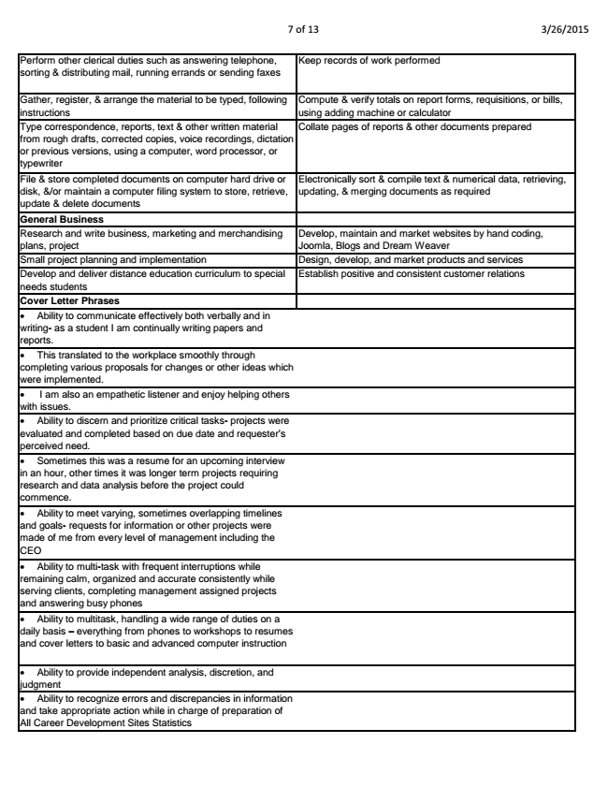

7 of 13 3/26/2015

Perform other clerical duties such as answering telephone, sorting & distributing mail, running errands or sending faxes

Keep records of work performed

Gather, register, & arrange the material to be typed, following instructions

Compute & verify totals on report forms, requisitions, or bills, using adding machine or calculator Type correspondence, reports, text & other written material from rough drafts, corrected copies, voice recordings, dictation or previous versions, using a computer, word processor, or typewriter

Collate pages of reports & other documents prepared

File & store completed documents on computer hard drive or disk, &/or maintain a computer filing system to store, retrieve, update & delete documents

Electronically sort & compile text & numerical data, retrieving, updating, & merging documents as required

General Business Research and write business, marketing and merchandising plans, project

Develop, maintain and market websites by hand coding, Joomla, Blogs and Dream Weaver Small project planning and implementation Design, develop, and market products and services Develop and deliver distance education curriculum to special needs students

Establish positive and consistent customer relations

**Cover Letter Phrases**

• Ability to communicate effectively both verbally and in writing- as a student I am continually writing papers and reports.

• This translated to the workplace smoothly through completing various proposals for changes or other ideas which were implemented.

• I am also an empathetic listener and enjoy helping others with issues.

• Ability to discern and prioritize critical tasks- projects were evaluated and completed based on due date and requester’s perceived need.

• Sometimes this was a resume for an upcoming interview in an hour, other times it was longer term projects requiring research and data analysis before the project could commence.

• Ability to meet varying, sometimes overlapping timelines and goals- requests for information or other projects were made of me from every level of management including the CEO

• Ability to multi-task with frequent interruptions while remaining calm, organized and accurate consistently while serving clients, completing management assigned projects and answering busy phones

• Ability to multitask, handling a wide range of duties on a daily basis – everything from phones to workshops to resumes and cover letters to basic and advanced computer instruction

• Ability to provide independent analysis, discretion, and judgment

• Ability to recognize errors and discrepancies in information and take appropriate action while in charge of preparation of All Career Development Sites Statistics

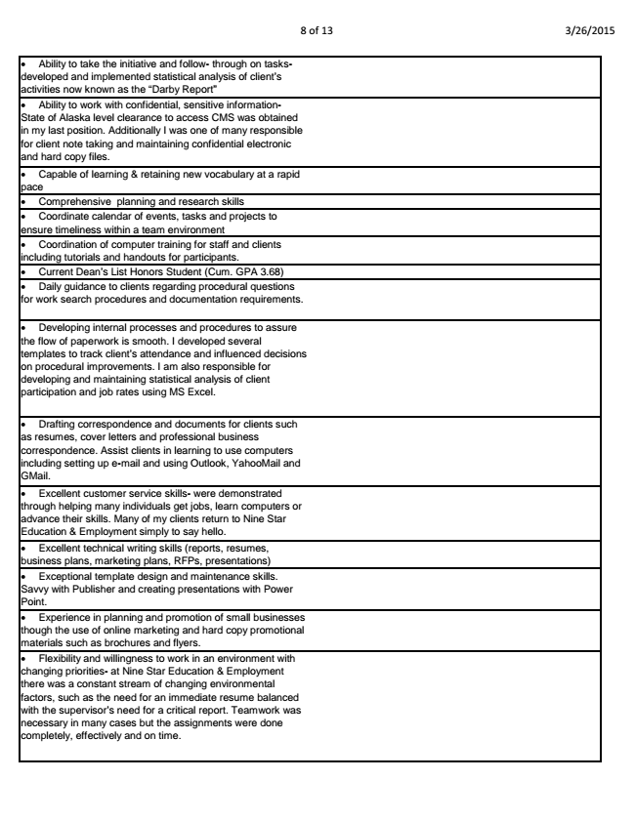

8 of 13 3/26/2015

• Ability to take the initiative and follow- through on tasks- developed and implemented statistical analysis of client’s activities now known as the “Darby Report”

• Ability to work with confidential, sensitive information- State of Alaska level clearance to access CMS was obtained in my last position. Additionally I was one of many responsible for client note taking and maintaining confidential electronic and hard copy files.

• Capable of learning & retaining new vocabulary at a rapid pace

• Comprehensive planning and research skills

• Coordinate calendar of events, tasks and projects to ensure timeliness within a team environment

• Coordination of computer training for staff and clients including tutorials and handouts for participants.

• Current Dean’s List Honors Student (Cum. GPA 3.68)

• Daily guidance to clients regarding procedural questions for work search procedures and documentation requirements.

• Developing internal processes and procedures to assure the flow of paperwork is smooth. I developed several templates to track client’s attendance and influenced decisions on procedural improvements. I am also responsible for developing and maintaining statistical analysis of client participation and job rates using MS Excel.

• Drafting correspondence and documents for clients such as resumes, cover letters and professional business correspondence. Assist clients in learning to use computers including setting up e-mail and using Outlook, YahooMail and GMail.

• Excellent customer service skills- were demonstrated through helping many individuals get jobs, learn computers or advance their skills. Many of my clients return to Nine Star Education & Employment simply to say hello.

• Excellent technical writing skills (reports, resumes, business plans, marketing plans, RFPs, presentations)

• Exceptional template design and maintenance skills. Savvy with Publisher and creating presentations with Power Point.

• Experience in planning and promotion of small businesses though the use of online marketing and hard copy promotional materials such as brochures and flyers.

• Flexibility and willingness to work in an environment with changing priorities- at Nine Star Education & Employment there was a constant stream of changing environmental factors, such as the need for an immediate resume balanced with the supervisor’s need for a critical report. Teamwork was necessary in many cases but the assignments were done completely, effectively and on time.

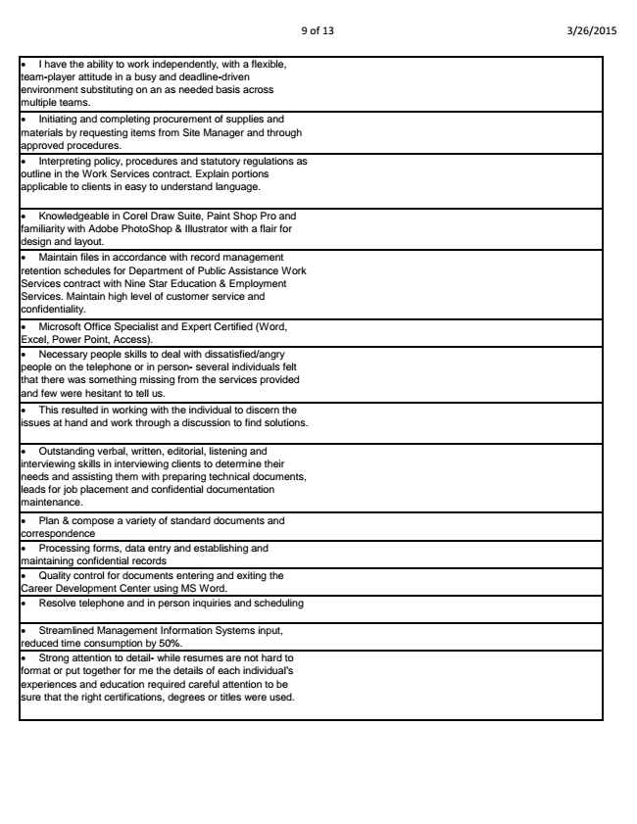

9 of 13 3/26/2015

• I have the ability to work independently, with a flexible, team-player attitude in a busy and deadline-driven environment substituting on an as needed basis across multiple teams.

• Initiating and completing procurement of supplies and materials by requesting items from Site Manager and through approved procedures.

• Interpreting policy, procedures and statutory regulations as outline in the Work Services contract. Explain portions applicable to clients in easy to understand language.

• Knowledgeable in Corel Draw Suite, Paint Shop Pro and familiarity with Adobe PhotoShop & Illustrator with a flair for design and layout.

• Maintain files in accordance with record management retention schedules for Department of Public Assistance Work Services contract with Nine Star Education & Employment Services. Maintain high level of customer service and confidentiality.

• Microsoft Office Specialist and Expert Certified (Word, Excel, Power Point, Access).

• Necessary people skills to deal with dissatisfied/angry people on the telephone or in person- several individuals felt that there was something missing from the services provided and few were hesitant to tell us.

• This resulted in working with the individual to discern the issues at hand and work through a discussion to find solutions.

• Outstanding verbal, written, editorial, listening and interviewing skills in interviewing clients to determine their needs and assisting them with preparing technical documents, leads for job placement and confidential documentation maintenance.

• Plan & compose a variety of standard documents and correspondence

• Processing forms, data entry and establishing and maintaining confidential records

• Quality control for documents entering and exiting the Career Development Center using MS Word.

• Resolve telephone and in person inquiries and scheduling

• Streamlined Management Information Systems input, reduced time consumption by 50%.

• Strong attention to detail- while resumes are not hard to format or put together for me the details of each individual’s experiences and education required careful attention to be sure that the right certifications, degrees or titles were used.

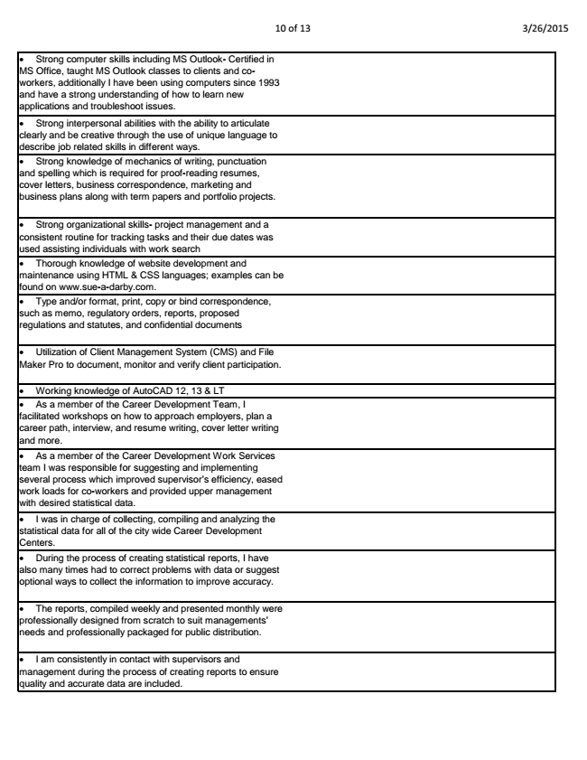

10 of 13 3/26/2015

• Strong computer skills including MS Outlook- Certified in MS Office, taught MS Outlook classes to clients and co- workers, additionally I have been using computers since 1993 and have a strong understanding of how to learn new applications and troubleshoot issues.

• Strong interpersonal abilities with the ability to articulate clearly and be creative through the use of unique language to describe job related skills in different ways.

• Strong knowledge of mechanics of writing, punctuation and spelling which is required for proof-reading resumes, cover letters, business correspondence, marketing and business plans along with term papers and portfolio projects.

• Strong organizational skills- project management and a consistent routine for tracking tasks and their due dates was used assisting individuals with work search

• Thorough knowledge of website development and maintenance using HTML & CSS languages; examples can be found on www.sue-a-darby.com.

• Type and/or format, print, copy or bind correspondence, such as memo, regulatory orders, reports, proposed regulations and statutes, and confidential documents

• Utilization of Client Management System (CMS) and File Maker Pro to document, monitor and verify client participation.

• Working knowledge of AutoCAD 12, 13 & LT

• As a member of the Career Development Team, I facilitated workshops on how to approach employers, plan a career path, interview, and resume writing, cover letter writing and more.

• As a member of the Career Development Work Services team I was responsible for suggesting and implementing several process which improved supervisor’s efficiency, eased work loads for co-workers and provided upper management with desired statistical data.

• I was in charge of collecting, compiling and analyzing the statistical data for all of the city wide Career Development Centers.

• During the process of creating statistical reports, I have also many times had to correct problems with data or suggest optional ways to collect the information to improve accuracy.

• The reports, compiled weekly and presented monthly were professionally designed from scratch to suit managements’ needs and professionally packaged for public distribution.

• I am consistently in contact with supervisors and management during the process of creating reports to ensure quality and accurate data are included.